Lab 5.
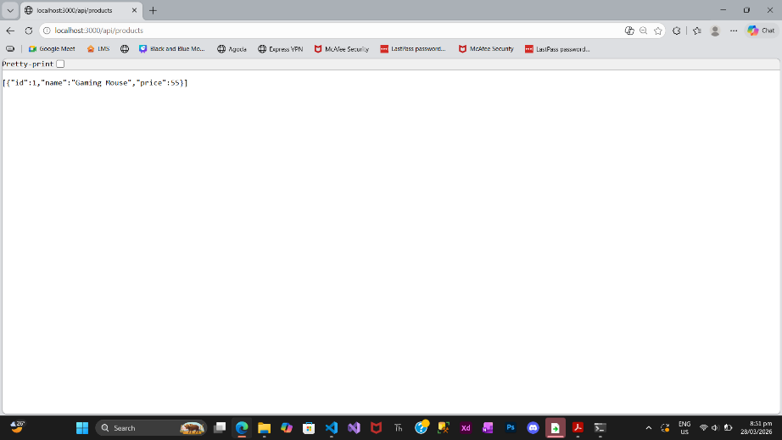
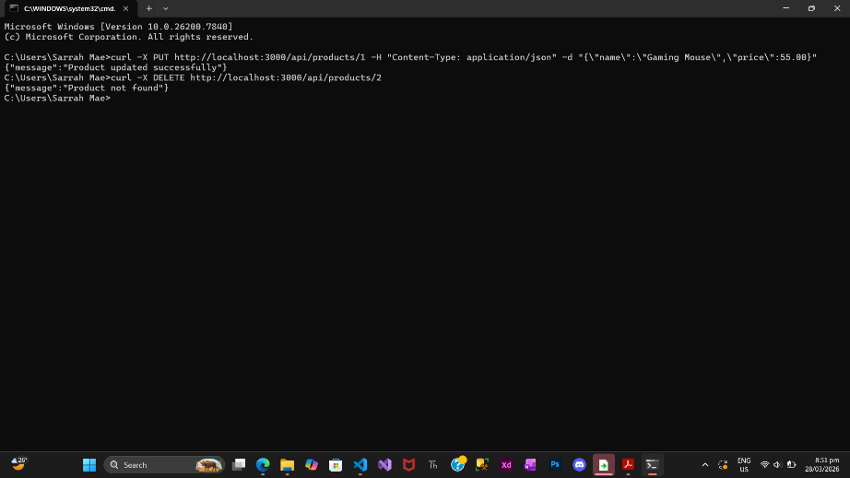
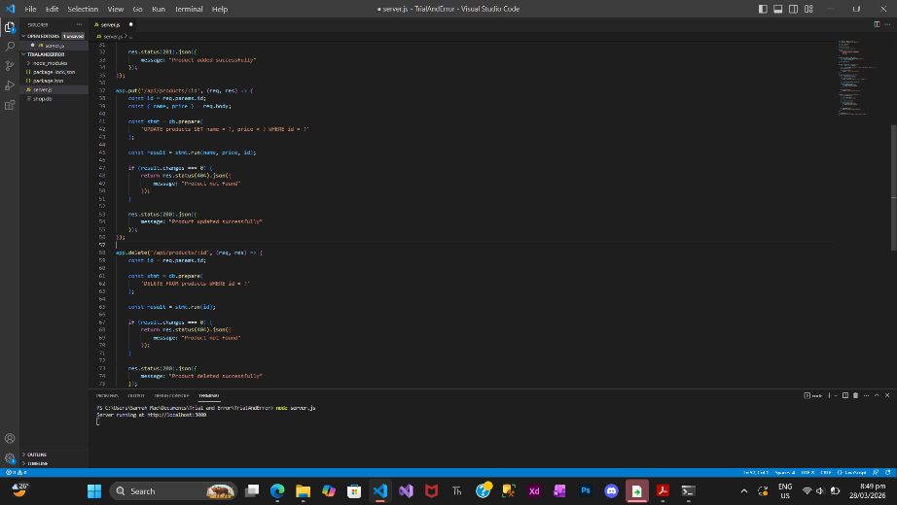

Questions:
- Why is PUT used for updating data instead of POST? Think about the "Strict Synchronous Contract".
- PUT is used for updating data because it follows a strict and predictable contract. It updates an existing resource at a specific URL like /api/products/1. In contrast, POST is used to create new data and does not guarantee idempotency. PUT ensures that repeated requests will produce the same result, making it suitable for updates.

- In your DELETE logic, why is it better to return a 404 error if the ID doesn't exist, rather than just sending a "Success" message anyway?
- Returning a 404 error is important because it accurately informs the client that the requested resource does not exist. Sending a success message even when nothing was deleted would be misleading and could cause data inconsistencies or confusion in the application.

- You’ve now built a full CRUD API. If you were to connect a React or Mobile app to this, which part of the "Modern API Architecture" would this Node.js server represent?
- This Node.js server represents the Backend (API Layer) in modern API architecture. It handles business logic, processes requests, interacts with the database, and sends responses to clients such as web or mobile applications.

